Instructions: Use this template to draft the project deliverables. You may modify the template to include more information.
Step I: Current system assessment
- System architecture overview

Current System | Key Findings
Legacy point-of-sale | The retailer uses Windows CE-based terminals with slow transaction processing, for example, more than 5 seconds for checkout. They also use outdated card reader drivers from 2009.
E-commerce platform | The platform used is Magento 1.9 running on a separate MySQL database. The performance is poor, for example, a cumulative layout shift greater than 0.25 and a page load greater than 2 seconds on 4G.
Data storage | The retailer has deployed on-premise SQL databases per store, with nightly batch updates to headquarters, leading to fragmented data and inconsistent customer profiles.
Inventory management: | Manual processes using Excel spreadsheets, causing stockouts and delayed reordering.
- Pain-points matrix
Pain point | Impact | Root cause
Checkout delays | Reduced conversion rates | Slow POS processing on Windows CE
Restocking | Loss of Potential Customer | Manual processes lead to stockouts and production delays.
Marketing | Loss of potential leads | Splitting email lists by channel hinders targeted campaigns

3. Key inefficiencies
The retailer’s current architecture severely restricts both agility (ability to adapt quickly) and scalability (ability to handle growth and peak demand). This is mainly due to fragmented systems, outdated infrastructure, and manual operational processes.

1. Legacy POS limits agility and performance
The Windows CE-based POS terminals are outdated and require more than 5 seconds per transaction. Because the technology is obsolete and dependent on outdated drivers (2009), upgrades or integration with modern payment systems and omnichannel features become difficult and slow.
Impact: Any improvement in checkout experience requires major hardware and software replacement, slowing innovation.

2. Separate e-commerce platform creates system fragmentation
Magento 1.9 runs independently on a separate MySQL database and suffers from poor performance (page load >2 seconds on 4G and high layout shift). Since it is not tightly integrated with POS and inventory systems, online and in-store operations cannot work as one unified platform.
Impact: The business cannot rapidly launch features like BOPIS, real-time promotions, or unified loyalty programs.

3. Decentralized store databases block scalability
Each store maintains its own on-premise SQL database, with only nightly batch updates to headquarters. This creates data fragmentation and delays in visibility across locations.
Impact: The system cannot scale efficiently because data is inconsistent, delayed, and difficult to consolidate for analytics and decision-making.

4. Batch updates prevent real-time decision-making
Nightly batch synchronization means inventory and customer data is always outdated. This prevents real-time stock updates and accurate customer profiling across channels.
Impact: The retailer cannot respond quickly to demand spikes, leading to stockouts and lost revenue.

5. Manual inventory processes reduce operational efficiency
Inventory management relies heavily on Excel spreadsheets and manual tracking. This increases human error and slows down restocking and reordering processes.
Impact: Scaling operations becomes impossible without increasing staff workload and operational costs.

Conclusion
Overall, the retailer’s architecture is rigid and disconnected, preventing fast feature delivery and real-time operations. These inefficiencies reduce agility by making changes slow and costly, and reduce scalability by limiting the system’s ability to support growth, peak traffic, and unified omnichannel experiences.
—------------------------------

Step II: Stakeholder requirements
- Stakeholder identification
Stakeholder | Interests
Customers | Fast purchases, unified cart, real-time stock visibility
Store Staff | They require POS with transactions less than 5 seconds and inventory visibility for quick lookups
IT Team | They prioritize maintainability, security, and compliance (for example, API-first, GDPR).
Management | They need data-driven insights via a single customer view and margin analytics.

2. Requirements
Functional requirements:
ID | Requirement | Justification
FR01 | Process in-store sales in ≤5s | Addresses checkout delays for customers and staff
FR02 | Real-time inventory decrement on any channel | Keep customer informed about the product stock
FR03 | 360° customer profile exposed via API | Central dashboard for emailing and marketing campaign
FR04 | Support buy online pickup in-store (BOPIS) | Speed Up the purchasing process,  Increase in volume of customers

Non-functional requirements:
ID | Requirement | Justification
NFR01 | System availability ≥ 99.9% | Ensures reliable operations for all stakeholders
NFR02 | Page load in less than 2 seconds on 4G | Increase in customer engagement
NF03 | Scaling>3 times on peak season | No loss of customer during peak season

Step III: Alternative solution evaluation
- Comparative analysis
Compare three proposed solutions based on the evaluation criteria: Functional fit (40%), scalability (20%), total cost of ownership (20%), implementation risk (10%), vendor viability (10%).
Criteria | Weight | Salesforce Commerce Cloud + POS | Shopify Plus + Square POS | Custom Microservices
Functional fit | 40% | 9/10 | 10/10 | 9/10
Scalability | 20% | 10/10 | 7/10 | 10/10
Cost (Year 1) | 20% | $150,000 (Year 1) | $50,000 (year 1) | $300,000 (year 1)
Implementation risk | 10% | 6 months | 3 months | 12 months
Vendor viability | 10% | 10 | 10 | 25
Total score | 100% | 8.4 | 9.4 | 5.2
- Recommended solution
Every service provider solves different requirements of stakeholders.
Considering the table Below:

Feature | SalesForce | Shopify Plus | Custom Microservice
Cost | Moderate | Lowest | High
Scalability | High | Moderate | High
Risk | Moderate | Low | High

- Trade-offs

1. Cost vs Scalability
- Shopify Plus + Square POS provides the lowest Year 1 cost ($50,000), making it the most budget-friendly option. However, its scalability is moderate (7/10) compared to the others, meaning it may require additional upgrades or integrations as the business grows aggressively.
- Salesforce Commerce Cloud is more expensive ($150,000) but offers excellent scalability (10/10), making it better suited for long-term enterprise growth.
- Custom Microservices offer top scalability (10/10) but at the highest cost ($300,000), which increases financial risk.
Trade-off: Shopify wins on cost, Salesforce wins on scalability, custom microservices are powerful but financially heavy.

2. Speed of Deployment vs Customization
- Shopify Plus supports the fastest deployment (3 months) due to its ready-made ecosystem, templates, and integrations. But customization is limited to platform constraints.
- Salesforce offers more customization than Shopify but requires longer implementation (6 months) because of configuration complexity.
- Custom Microservices provide maximum customization and control, but take the longest time (12 months) and carry higher chances of delays.
Trade-off: Shopify is fastest, custom microservices are most customizable but slowest.

3. Risk vs Control
- Shopify has low implementation risk because it is stable SaaS with strong vendor support.
- Salesforce has moderate risk due to integration complexity.
- Custom microservices have the highest risk because the organization must manage architecture, testing, security, scaling, and maintenance internally.
Trade-off: Shopify reduces risk, but custom microservices give maximum control at high risk.

Conclusion
Shopify Plus + Square POS is the best solution for quick deployment, low cost, and reduced risk, but sacrifices some scalability and deep customization. Salesforce is stronger for long-term enterprise scalability but costs more. Custom microservices offer maximum flexibility and scalability, but the high cost and long implementation time make it unsuitable for a retailer needing immediate modernization.

Step IV: Feasibility and risk analysis

4.1 Feasibility Assessment

Technical Feasibility
The recommended solution is technically feasible because Shopify Plus and Square POS are cloud-based SaaS platforms designed with an API-first architecture. Integration with existing enterprise systems can be achieved through REST APIs, requiring only a minimal on-premises footprint. This reduces infrastructure complexity and accelerates deployment.

Economic Feasibility
Economically, Shopify Plus offers the lowest Year 1 cost among the evaluated options and demonstrates a positive Net Present Value (NPV) over five years. This makes it financially viable and reduces the risk of capital overrun compared to custom microservices, which remain negative in NPV until Year 4.

Operational Feasibility
Operational feasibility is strong because the solution requires limited change management. Staff upskilling is achievable within eight weeks, and the overall implementation aligns with the retailer’s nine-month timeline, ensuring minimal disruption during peak seasonal sales cycles.

- Risk analysis
Risk | Probability | Impact | Risk score | Mitigation
Data migration loss | 3 | 4 | 12 | Two dry runs, checksum validation
Vendor outage | 2 | 5 | 10 | SLA 99.9%, rollback POS offline mode
- Mitigation effectiveness
The recommended solution (for example, Shopify Plus for quick deployment) is technically feasible due to cloud compatibility and API-first design. Economically, it offers the lowest initial cost and positive returns within five years. Operationally, it requires minimal staff retraining. Risks like data migration and vendor outages are manageable with robust mitigation strategies, ensuring alignment with the nine-month timeline.
The identified risks are significant, but the mitigation strategies ensure the project remains achievable within the nine-month implementation timeline.

1. Data Migration Loss (Score: 12)
Data migration is a high-impact risk because loss or corruption of customer, inventory, or transaction data can delay go-live. However, performing two dry-run migrations allows the team to detect missing records, mapping issues, and formatting errors early in the project. Additionally, checksum validation ensures that the migrated data matches the source data accurately.
How this supports the 9-month timeline:
Dry runs reduce last-minute failures, prevent rework during final deployment, and ensure the final migration can be executed smoothly during the planned cutover window.

Vendor Outage (Score: 10)
Vendor downtime can disrupt sales operations, especially during peak business hours. This risk is mitigated through a 99.9% SLA agreement, which ensures high service availability. In addition, enabling POS offline rollback modernsures transactions can continue even if the cloud service becomes temporarily unavailable.
How this supports the 9-month timeline:
This mitigation prevents operational disruption during pilot and rollout phases, ensuring testing and deployment can proceed without delays caused by vendor instability.

Conclusion
Overall, the mitigation strategies reduce the probability of critical failures during implementation. By ensuring reliable migration and operational continuity, the retailer can confidently complete testing, pilot deployment, and full rollout within the planned nine-month schedule, while minimizing disruption to daily business operations.

Step V: Visualizations and recommendations
- Results and visualizations
After analyzing the entire system I came to the conclusion that by integrating different departments and synchronizing their data we can manage the potential delays store is facing
Visual artefact
Data Flow Diagram
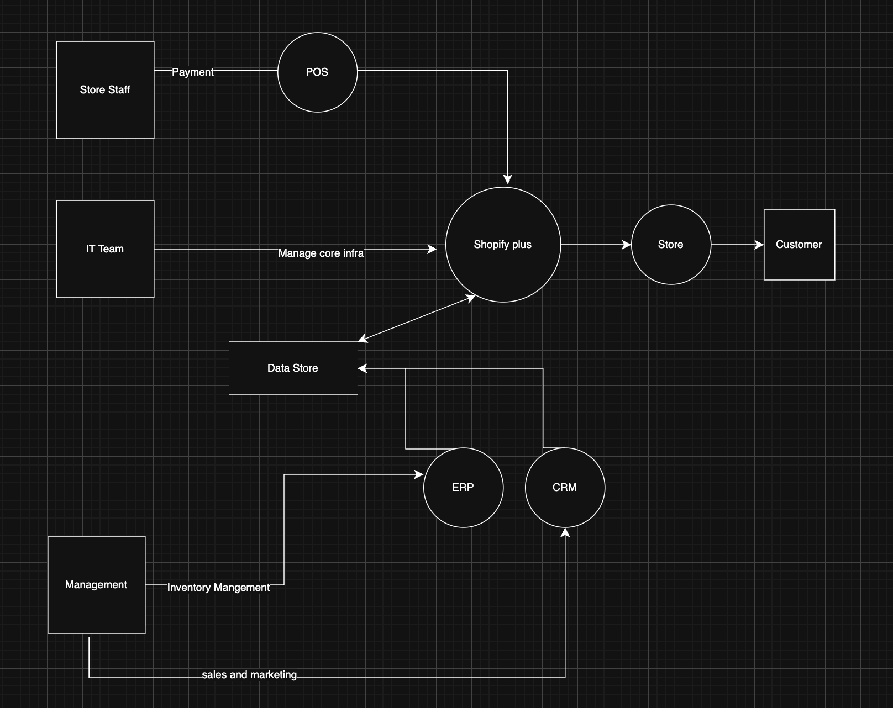

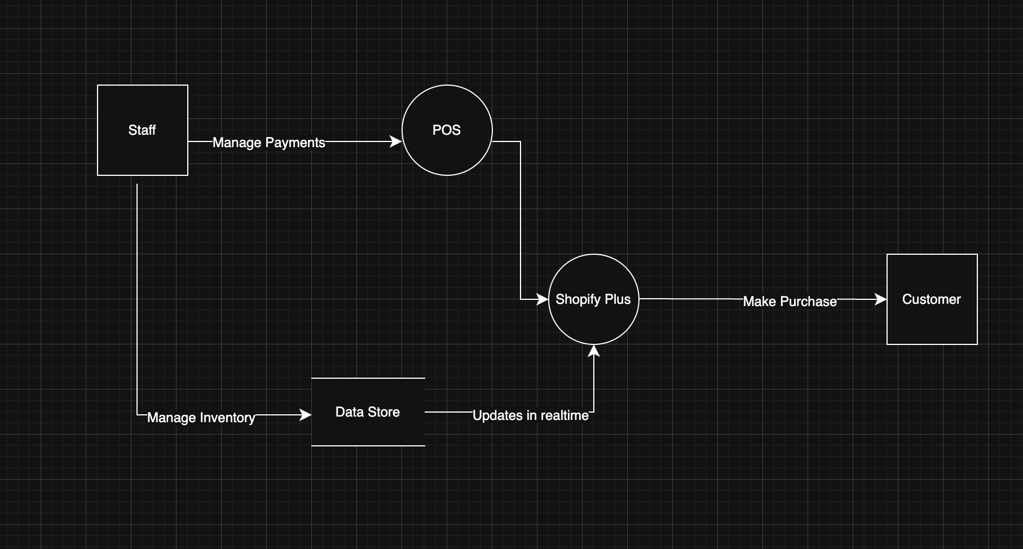
Staff Flow

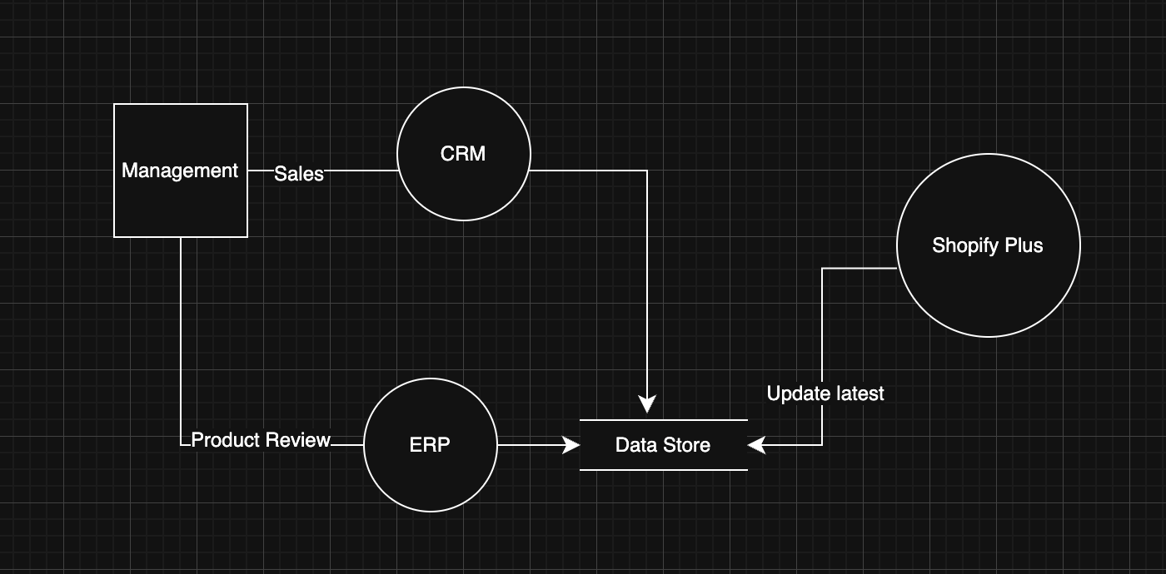
Management Flow

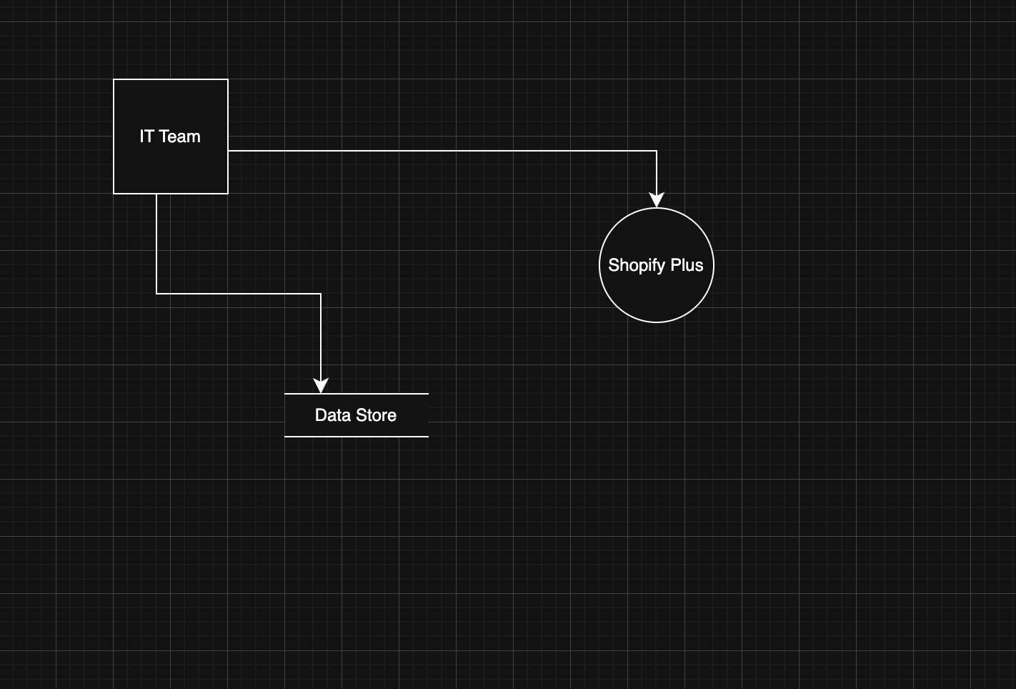
IT Team Flow

Implementation roadmap

Milestone | Timeline | Description
M1: Project Kickoff & Requirement Finalization | Month 1 | Confirm functional + non-functional requirements (FR01–FR04, NFR01–NFR03), finalize scope, assign project team, and approve implementation plan.
M2: Solution Design & Architecture Planning | Month 2 | Define system architecture, API integration plan, data flow design, and security model. Prepare migration and testing strategy.
M3: Shopify Plus + Square POS Setup | Month 3 | Configure Shopify Plus storefront, payment setup, Square POS integration, tax rules, product catalog structure, and store workflows.
M4: Integration Development (ERP, CRM, Inventory APIs) | Month 4 | Build and test REST API integrations for inventory sync, customer profile (360° view), and order management across channels.
M5: Data Migration Dry Run #1 | Month 5 | Perform first migration trial (products, customers, orders, inventory). Validate using checksum checks and resolve missing/inconsistent records.
M6: User Training & Operational Readiness | Month 6 | Upskill store staff and operations team (POS training, BOPIS workflow, inventory management). Create SOPs and support manuals.
M7: Data Migration Dry Run #2 + Performance Testing | Month 7 | Conduct second migration dry run and load testing to validate ≤5s checkout time, 99.9% availability readiness, and scaling for peak season.
M8: Pilot Launch (Selected Stores + Online) | Month 8 | Go-live in limited stores to validate real-world POS performance, BOPIS, inventory accuracy, and customer experience. Collect feedback and fix issues.
M9: Full Rollout + Go-Live Support | Month 9 | Deploy solution across all stores, enable full omnichannel operations, monitor stability, ensure SLA compliance, and provide hypercare support post-launch.

